CoreNFC is only available on iPhone 7 and iPhone 7 Plus devices. Make sure you're running your code on one of those.

See the WWDC session and the relevant documentation for more information.

<https://developer.apple.com/videos/play/wwdc2017/718/>

otherwise you get following error:

**yld: Library not loaded: /System/Library/Frameworks/CoreNFC.framework/CoreNFC**

**Referenced from: /var/containers/Bundle/Application/1B7CD17A-EDB7-4408-A615-E356C2955F8B/NFC-Example.app/NFC-Example**

**Reason: image not found**

There are a few things we need to do before we type the first line of code. To support NFC, the project needs a few tweaks. CoreNFC is an entitlement-protective framework, so the first thing to do is turn on the *Near Field Communication Tag Reading* feature inside your project’s *Capabilities* section.

The next step to add a “Privacy — NFC Scan Usage Description” text key value (the text your app will present to a user when using NFC) in your app’s info.plist file.

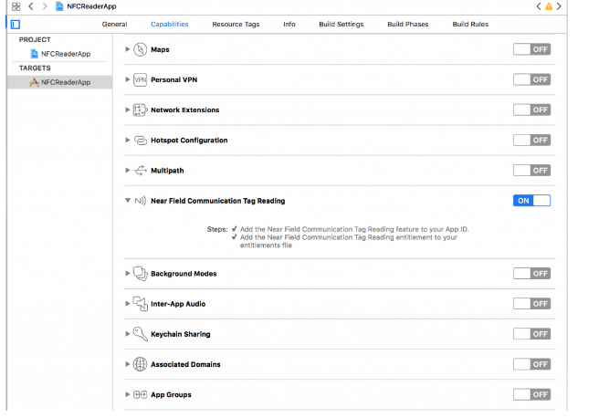

The next step to add a “Privacy — NFC Scan Usage Description” text key value (the text your app will present to a user when using NFC) in your app’s info.plist file.

